**Buy real passport online**

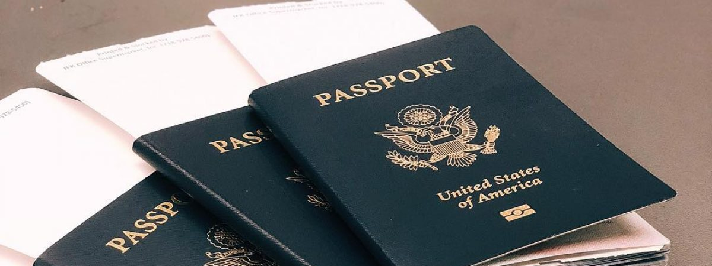

All fake documents online offer the best documents services ever. That you are hoping to buy an original passport online On the off chance. Buy original passport, scanable passport, how to get a passport, online passport apply, the quickest method to get a passport, least demanding nation to get citizenship. You are in the correct blemish. Buy original passport online we equip an original enrolled passport with all the customer bio-metric subtleties enrolled under the nation database framework. Diverse countries have made frequently unique methodology to separate the original and false global passports. Scan Novelty documents online Scan Novelty documents online. The Immigration Control is for the most part helped by bright lights set at the Immigration counters in the universal air terminals. The UV lights help perceive certain features buried in the photos of movement papers and visas, conventionally not evident to exposed eyes. All fake documents online deal with all these critical confirmation forms with no mix-ups and furthermore give the diverse sorts of original passports.

​All fake documents online offer the best documents services ever. On the off chance that you are hoping to buy a original passport online. Buy original passport, scanable passport, how to get a passport, online passport apply, the quickest method to get a passport, most effortless nation to get citizenship. You are at the opportune iota buy original passport

**Providing Services For :-**

* **Passports**
* **Driving License**
* **IELTS**
* **Citizenship Applications**
* **Diplomas and Certificates**

**Email :-** [***info@allfakedocumentsonline.com***](mailto:info@allfakedocumentsonline.com)

**Contact :-** *+23777420464*

**Website:-** *https://www.allfakedocumentsonline.com/*